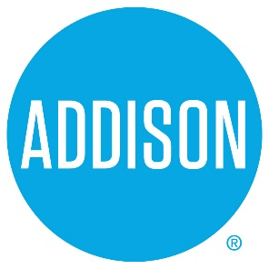

Bond Advisory Committee
Agenda
Session Two
February 11, 2019
5:30 – 7:30

- Welcome and Introductions Ralph Doherty

- Executive Perspective Wes Pierson

- Approval of Notes from January 30, 2019 Meeting Ralph Doherty

- Process Overview Ralph Doherty
  - February and March meetings

- Project Ranking Process Update Lisa Pyles

- Functional Review – General Services - Buildings Rob Bourestom

- Functional Area Prioritization Ralph Doherty, Bruce
Arfsten

  - Must Do, Should Do, Nice to Do

- Plans and next steps Lisa Pyles

- Closing All

