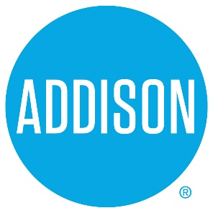

Bond Advisory Committee
Agenda
Session Two
February 25, 2019
5:30 – 7:30

- Welcome Ralph Doherty

- Approval of Notes from February 11, 2019 Meeting Ralph Doherty

- Functional Review – Infrastructure Jason Shroyer

- Project review discussion Committee
Ralph Doherty, Bruce Arfsten

- Closing All

