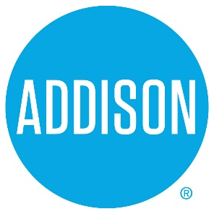

Bond Advisory Committee
Agenda
March 11, 2019
5:30 – 8:30

- Welcome Ralph Doherty

- Approval of Notes from February 25, 2019 Meeting Ralph Doherty

- Functional Review

  - General Services – Rob Bourestom
  - IT – Hamid Khaleghipour
  - Parks – Janna Tidwell
  - Land Acquisition – Charles Goff

- Project review discussion Committee
Ralph Doherty, Bruce Arfsten

- Next meeting – April 4, 2019, 5:30 to 7:50 Addison Tree House
  - Project ranking and cost estimates

- Closing All

