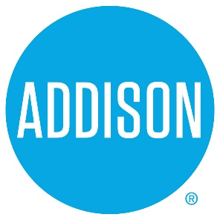

Bond Advisory Committee
Agenda
April 4, 2019
5:30 – 7:30

- Welcome Ralph Doherty

- Approval of Notes from March 11, 2019 Meeting Ralph Doherty

- Project Ranking Ralph Doherty, Committee

Keypad Voting Karen Walz
- Next meeting – April 18, 2019, 5:30 to 7:50 Addison Tree House
Municipal Finance and Debt Capacity

- Closing All

