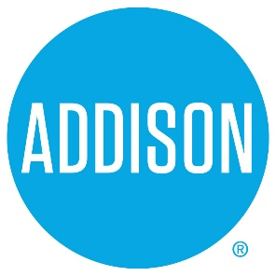

Bond Advisory Committee
Agenda
April 18, 2019
5:30 – 7:30

- Welcome Ralph Doherty

- Approval of Notes from April 4, 2019 Meeting Ralph Doherty

3. Financial Overview Olivia Riley, CFO and Nick Bulaich, Hilltop Securities

- Next meeting –
  - May 2, 2019, 5:30 to 7:50 Addison Tree House
Municipal Finance and Debt Capacity

- Closing Ralph Doherty

