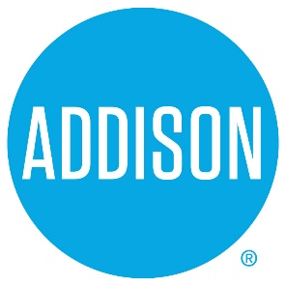

Bond Advisory Committee
Agenda
May 2, 2019
5:30 – 7:30

- Welcome Ralph Doherty

- Approval of Notes from April 18, 2019 Meeting Ralph Doherty

- Review Survey Results Lisa Pyles and Karen Walz

4. Discussion of Propositions Ralph Doherty

- Next meeting –
  - May 9, 2019, 5:30 to 7:50 Addison Tree House
Drafting the Report to Council

- Closing Ralph Doherty

