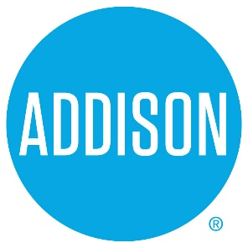

Bond Advisory Committee
Agenda
May 9, 2019
5:30 – 7:30

- Welcome Ralph Doherty

- Approval of Notes from May 2, 2019 Meeting Ralph Doherty

- Discuss Final Project Selection Ralph Doherty, Committee

4. Discussion of Propositions Ralph Doherty, Committee

- Discussion of DRAFT Final Report Ralph Doherty, Committee

- Next meeting –
  - May 23, 2019, 5:30 to 7:50 Addison Tree House
Final Report to Council

- Closing Ralph Doherty

