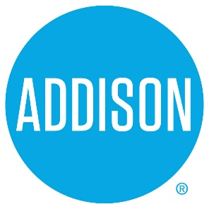

Bond Advisory Committee
Agenda
May 23, 2019
5:30 – 7:30

- Welcome Ralph Doherty

- Approval of Notes from May 9, 2019 Meeting Ralph Doherty

- Discussion of DRAFT Final Report Ralph Doherty, Committee

- Final Report to Council – June 11, 2019 Ralph Doherty

- Plans for June 11, 2019 Meeting Ralph Doherty

- Closing Ralph Doherty

